# Lab 1: Introduction to Machine Learning and Environment Setup

## 1. Introduction

In this lab, we introduce the basics of Machine Learning (ML) and demonstrate how to set up a dedicated Python environment for ML experiments. We'll use the built-in `venv` module to create a virtual environment named `myenv_abdurrehman`, where we will install essential ML libraries.

## 2. Objectives

- Understand what Machine Learning is.  
- Create an isolated virtual Python environment.  
- Install foundational ML libraries such as numpy, pandas, matplotlib, and scikit-learn.  
- Verify the environment setup with package installation.

## 3. Environment Setup Steps

1. Step 1: Open the Command Prompt (CMD)

Use the Start Menu to search and open 'cmd' or 'Command Prompt'.

1. Step 2: Create a Virtual Environment

Run the following command to create a virtual environment named `myenv_abdurrehman`:  
`python -m venv myenv_abdurrehman`

1. Step 3: Activate the Environment

Run the command below to activate the environment:  
`myenv_abdurrehman\Scripts\activate`

Screenshot: Creating and Activating the Environment

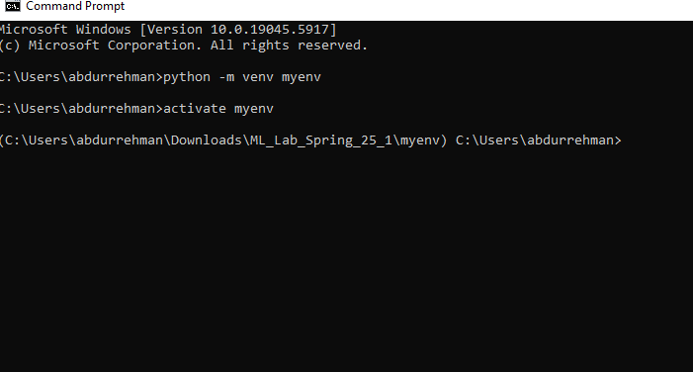

1. Step 4: Install Required Machine Learning Libraries

Use pip to install ML libraries:  
`pip install numpy pandas matplotlib scikit-learn`

Screenshot: Installing Libraries

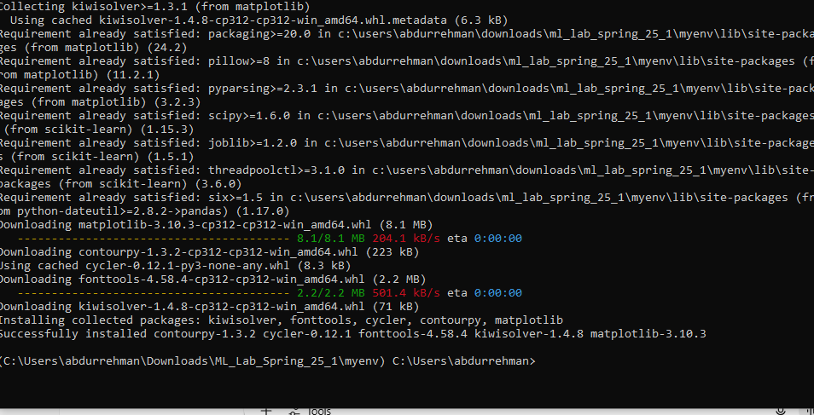

## 4. Conclusion

In this lab, you successfully created a Python virtual environment and installed key Machine Learning libraries. This setup ensures a clean, manageable, and reproducible workspace for all future ML projects.